**Assignment 25.2**

* **Write a Hive Program to find the total number of medals each country won**
* create table Olympic_data using create command with name,age,country,year,closing_date,sport,gold_medal,silver_medal ,bronze medal and total as columns.

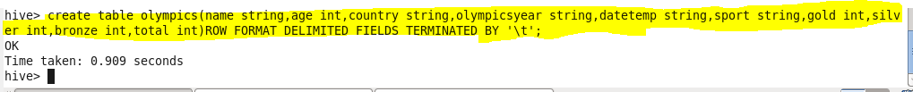

* We can check our table if created or not using show tables.

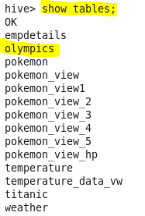

* now we will load our dataset Olympic_data.csv using LOAD command

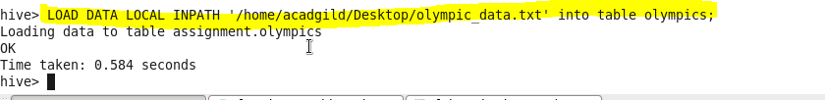

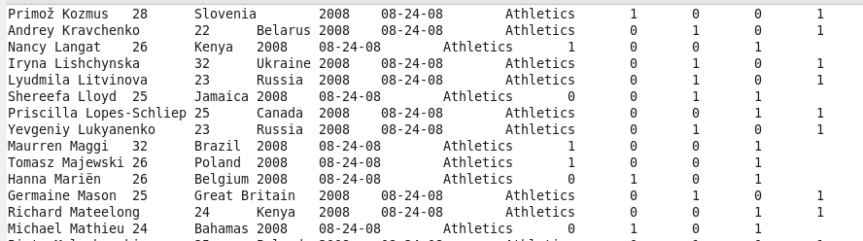

Since we want the number of medals won by each country hence we will group by country

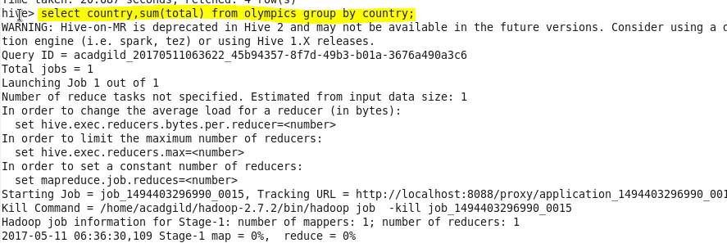

**Output:-**

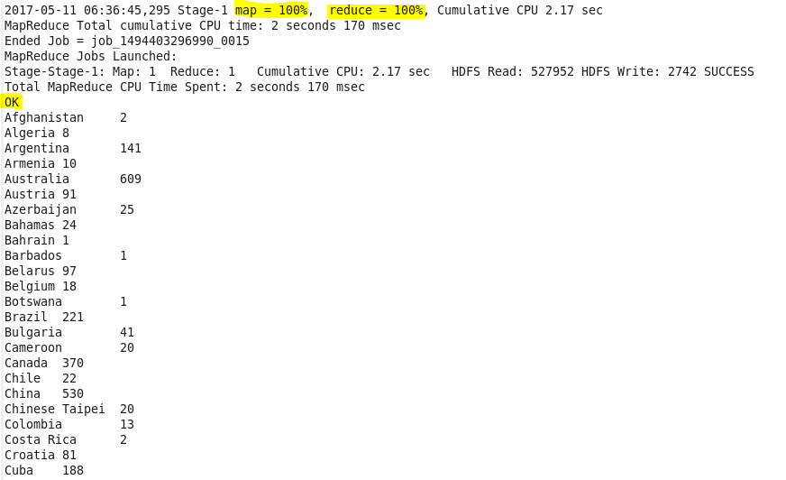

* **Write a Hive program to find the number of gold medals each country won**
* Since we want gold medal won by every country, so we will group our result by country and filter by medal equal to gold using where condition.

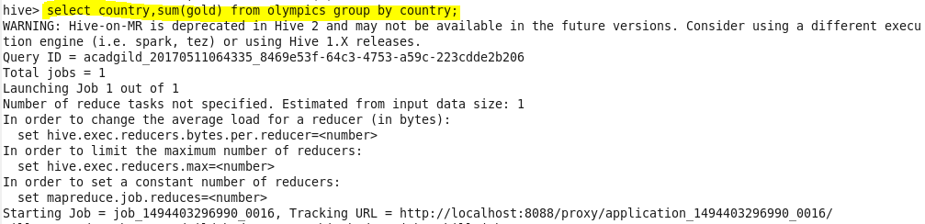

**Output:-**

